**Pengenalan MySQL**

1. Membuat database “toko”

Code:

|  |
| --- |
| CREATE DATABASE toko; |

Tampilan:

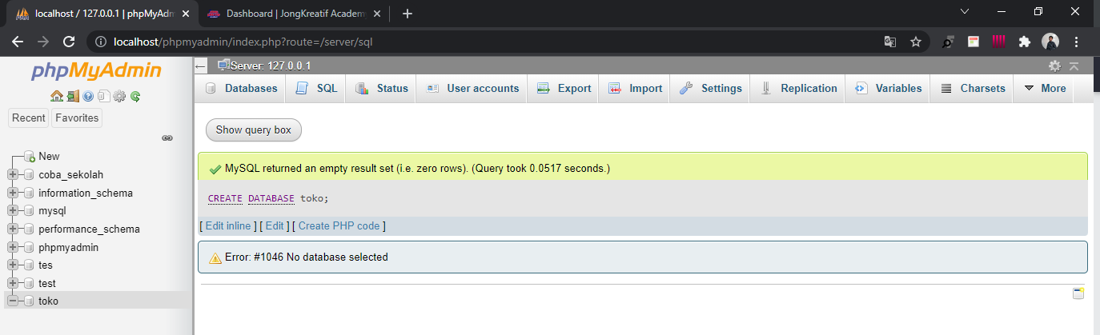

1. Membuat tabel bedasarkan ERD pelanggan dan barang

* Membuat tabel pelanggan

Code:

|  |
| --- |
| CREATE TABLE pelangan (  id_pelangan varchar(20) NOT NULL PRIMARY KEY,  nama_pelangan varchar(40) NOT NULL  ) |

Tampilan:

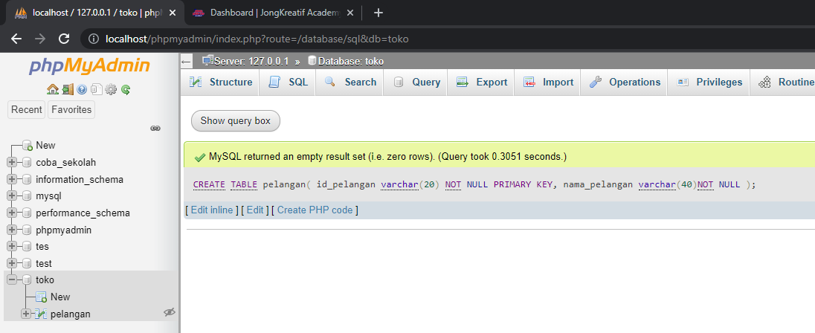

* Membuat tabel barang

Code:

|  |
| --- |
| CREATE TABLE barang(  id_barang varchar (20) NOT NULL PRIMARY KEY,  nama_barang varchar(30) NOT NULL,  harga int (10) NOT NULL  ) |

Tampilan:

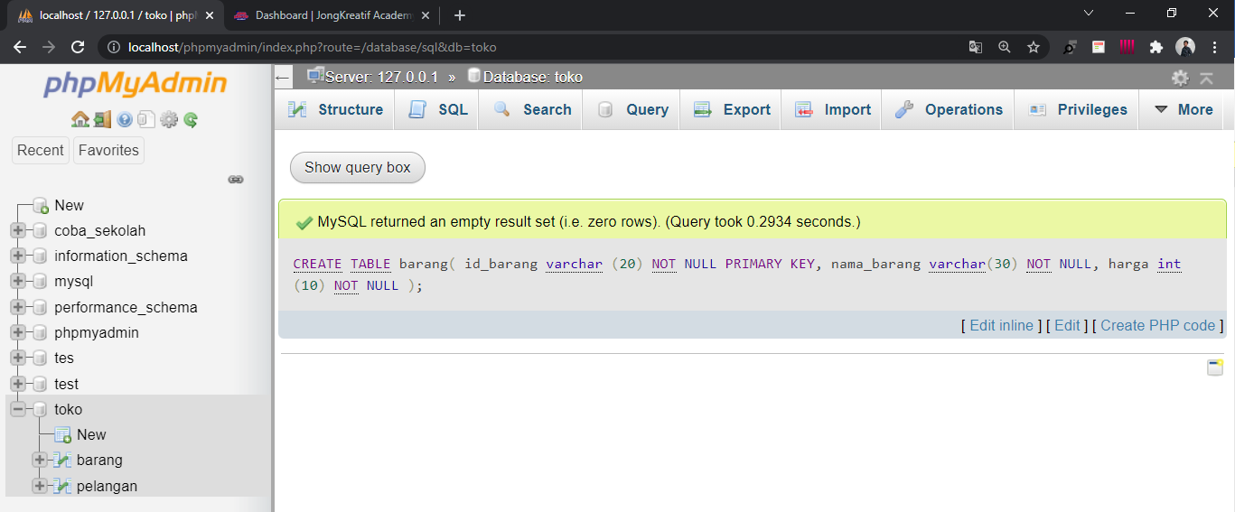

1. Mengisi data table pelanggan, minimal 10

Code:

|  |
| --- |
| INSERT INTO pelangan (id_pelangan,nama_pelangan) VALUES  ("20211001","Aulia Yunisa"),  ("20211002","Alimron Aida"),  ("20211003","Surip Suharto"),  ("20211004","Iwan Afandi"),  ("20211005","Saitama Susanto"),  ("20211006","Sulis Muazin"),  ("20211007","Zenrasid"),  ("20211008","Rahmayani"),  ("20211009","Winda Auliya"),  ("20211010","Putri Astutik") |

Tampilan:

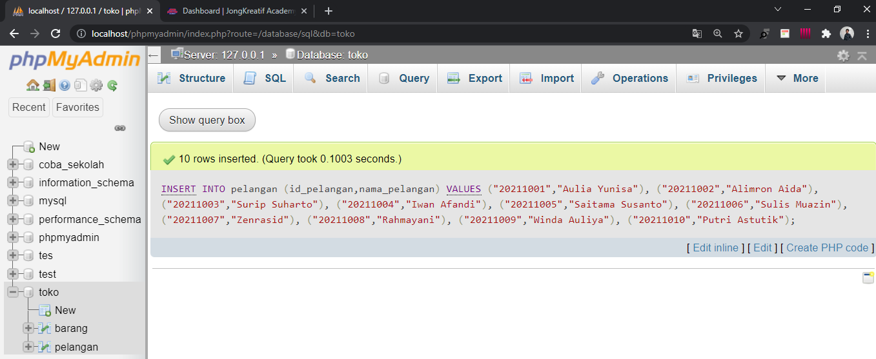

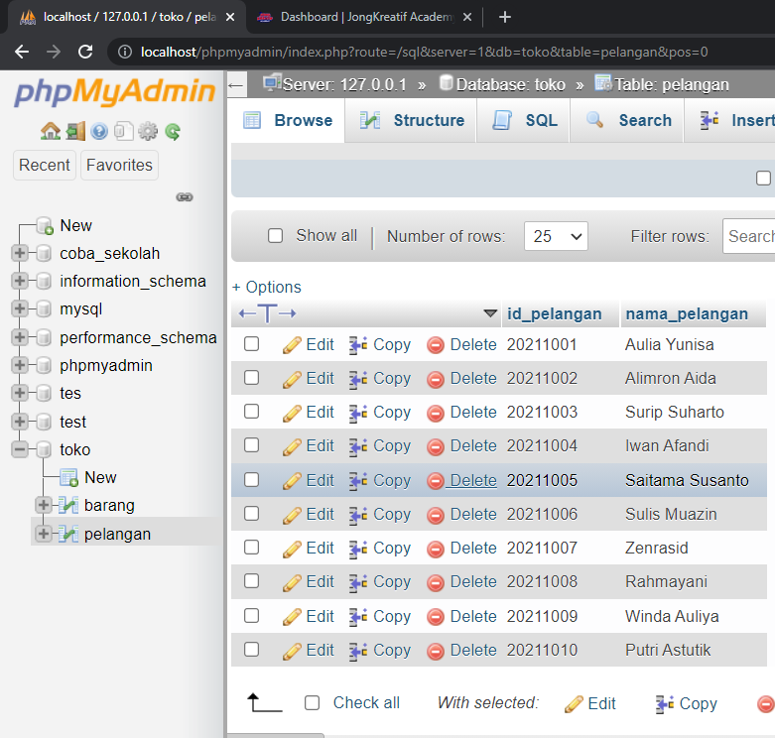

1. Mengisi data table barang, minimal berjumlah 10

Code:

|  |
| --- |
| INSERT INTO barang(id_barang,nama_barang,harga)VALUES  ("B0001","Monitor 1080P","2500000"),  ("B0002","Keyboard Game","510000"),  ("B0003","Mouse Game","250000"),  ("B0004","MousePad Game","80000"),  ("B0005","Mouse logitac","60000"),  ("B0006","Keyboard logitac","150000"),  ("B0007","Kabel VGA","30000"),  ("B0008","Flashdisk 16gb","50000"),  ("B0009","Hardisk 1TB","650000"),  ("B0010","Stop Kontak","15000") |

Tampilan:

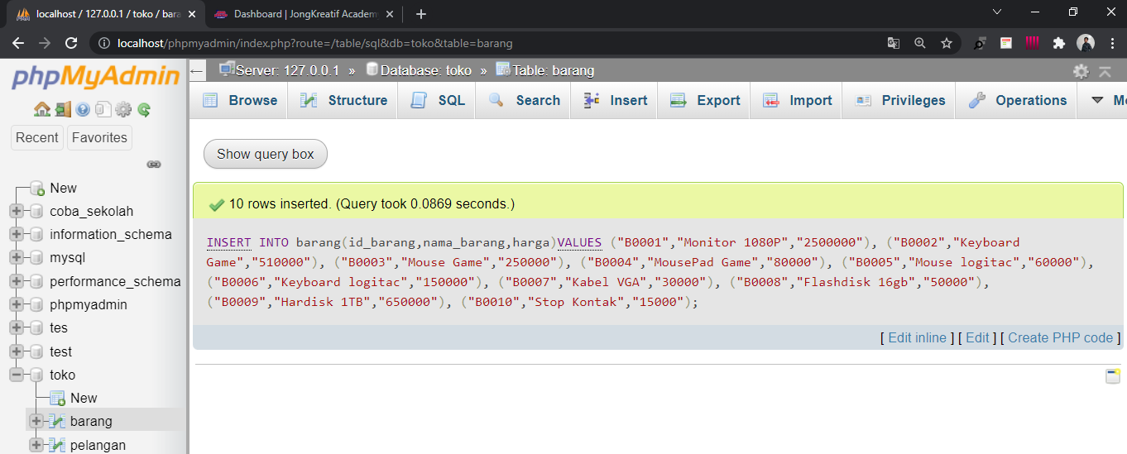

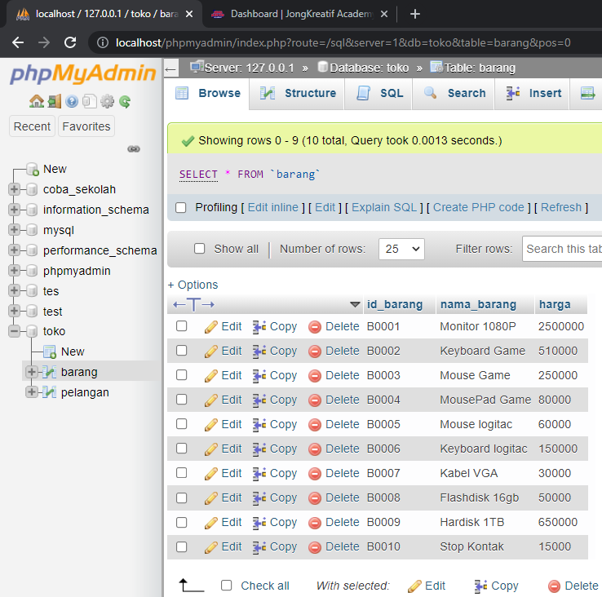

1. Interaksi jual-beli antara kedua tabel tersebut dalam tabel faktur dan fatur_barang, dalam satu transaksi minimal terdapat 3 barang, minimal 5 transaksi

* Membuat tabel faktur

Code:

|  |
| --- |
| CREATE TABLE faktur(  id_faktur varchar(10) NOT NULL PRIMARY KEY,  id_pelangan varchar(20) NOT NULL,  tanggal Date NOT NULL,  CONSTRAINT id_pelangan FOREIGN KEY (id_pelangan)REFERENCES pelangan(id_pelangan)  ) |

Tampilan:

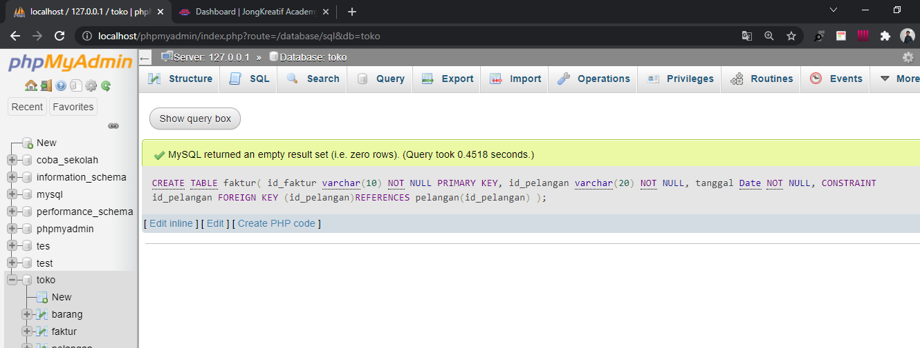

* Membuat tabel faktur_barang

Code:

|  |
| --- |
| CREATE TABLE faktur_barang (  id_barang varchar(20) NOT NULL,  id_faktur varchar(10) NOT NULL,  CONSTRAINT id_barang FOREIGN KEY (id_barang) REFERENCES barang (id_barang),  CONSTRAINT id_faktur FOREIGN KEY (id_faktur) REFERENCES faktur (id_faktur)  ) |

Tampilan:

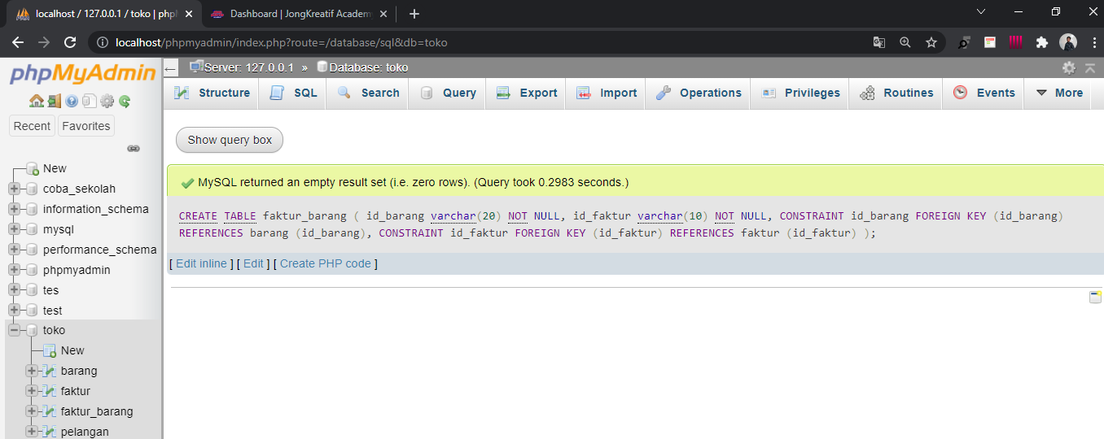

* mengisi data tabel faktur

Code:

|  |
| --- |
| INSERT INTO faktur(id_faktur,id_pelangan,tanggal) VALUES  ('F0001','20211001','2021-10-10'),  ('F0002','20211002','2021-10-10'),  ('F0003','20211004','2021-10-11'),  ('F0004','20211005','2021-10-12'),  ('F0005','20211008','2021-10-13'),  ('F0006','20211009','2021-10-14'),  ('F0007','20211010','2021-10-14') |

Tampilan:

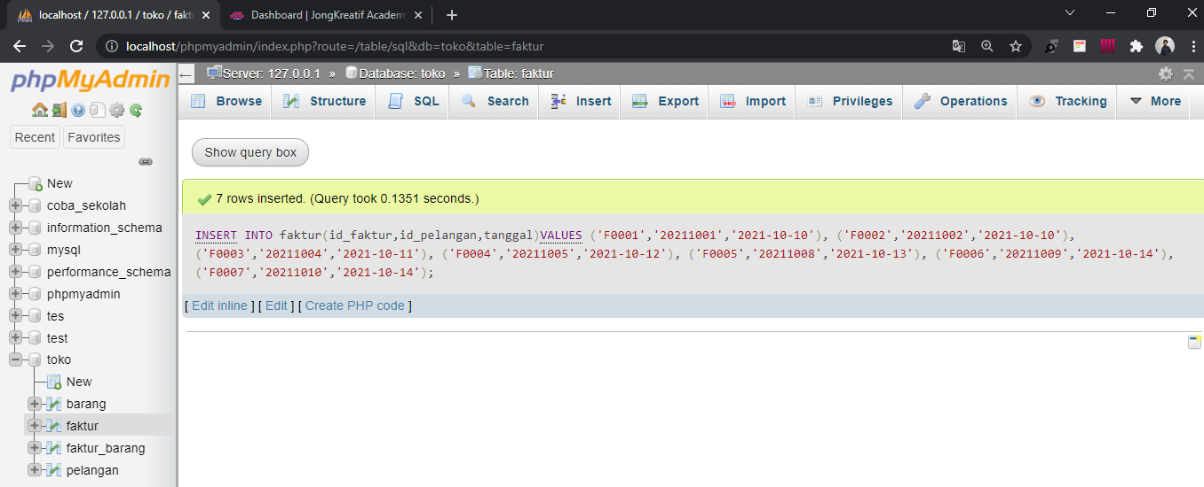

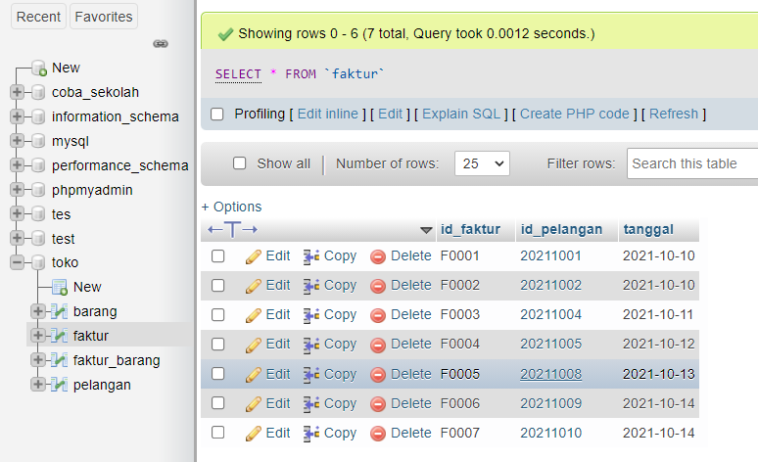

* mengisi data tabel faktur_barang

Code:

|  |
| --- |
| INSERT INTO faktur_barang (id_barang,id_faktur)VALUES  ("B0001","F0001"),  ("B0005","F0001"),  ("B0006","F0001"),  ("B0002","F0002"),  ("B0010","F0002"),  ("B0009","F0002"),  ("B0001","F0003"),  ("B0003","F0003"),  ("B0005","F0003"),  ("B0001","F0004"),  ("B0006","F0004"),  ("B0004","F0004"),  ("B0007","F0005"),  ("B0008","F0005"),  ("B0002","F0005"),  ("B0004","F0006"),  ("B0002","F0006"),  ("B0001","F0006"),  ("B0009","F0007"),  ("B0006","F0007"),  ("B0010","F0007") |

Tampilan:

